IR U 3 Probabilistic Retrieval Model
Probabilistic Retrieval is an information retrieval model that ranks documents based on the probability that a document is relevant to a given user query. The fundamental idea is that documents should be presented to the user in decreasing order of their probability of relevance.
The model estimates the probability P(R∣D) where R denotes relevance and D denotes a document. A document with a higher probability of relevance is ranked higher.
Probability Concepts Used
- The sample space is the entire document collection.
- Events include:
  - A document is relevant (R)
  - A document contains a term t
- Conditional probability is used to compute how likely a document is relevant given that it contains certain query terms.
Use of Bayes’ Theorem
Using Bayes’ theorem:
P(R∣D)=P(D∣R)⋅P(R)/P(D) Since P(D) is the same for all documents, ranking depends mainly on:
- P(D∣R): likelihood of the document given relevance
- P(R): prior probability of relevance
Term Independence Assumption
The model assumes term independence, meaning each query term contributes independently to relevance. Though not fully realistic, this assumption simplifies computation and enables efficient ranking.
Importance and Applications
- Forms the basis of the Binary Independence Model (BIM)
- Extended into practical ranking models such as BM25
- Supports relevance feedback to improve search results over time
Small Example Query: “machine learning”
Suppose:
- Term machine appears more frequently in relevant documents than non-relevant ones.
- Term learning also has high occurrence in relevant documents.
A document containing both terms will have a higher probability of relevance compared to documents containing only one or none of the terms. Hence, it will be ranked higher.
The Probability Ranking Principle (PRP): The 1/0 Loss Case
The Probability Ranking Principle (PRP) is a fundamental theory in Information Retrieval which states that:“For optimal retrieval performance, documents should be ranked in decreasing order of their probability of relevance to the user’s query.”
In the 1/0 loss case, the retrieval process assumes only two outcomes:
- Loss = 0 → if a relevant document is retrieved
- Loss = 1 → if a non-relevant document is retrieved
This means the system is punished only when it retrieves non-relevant documents, and there is no extra penalty for missing relevant ones.

Key Idea
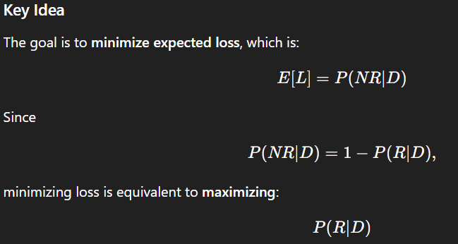
Thus, PRP dictates ranking documents by decreasing probability of relevance.

Why PRP Is Optimal
- It ensures that users see the most relevant documents first.
- It provides a mathematically sound ranking rule under uncertainty.
- It assumes perfect probability estimates, making the ranking theoretically optimal.

Assumptions
- Relevance is binary
- Loss for retrieving a relevant document = 0
- Loss for retrieving a non-relevant document = 1
- User prefers to avoid non-relevant documents

The Probability Ranking Principle (PRP) with Retrieval Costs
The basic PRP assumes equal loss for all retrieval errors. However, in real systems, different types of errors have different costs.

Realistic Scenario
- Missing a relevant document (false negative) may be very expensive
→ Example: medical diagnosis, legal information
- Retrieving a non-relevant document (false positive) may be less costly
Thus, losses are defined as:
- C₁ = cost of retrieving a non-relevant document
- C₂ = cost of not retrieving a relevant document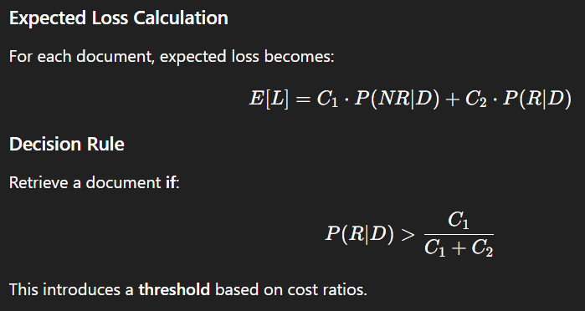

Interpretation
- If C₂ is large (missing relevant doc is costly)
→ Threshold becomes smaller
→ System retrieves more documents
- If C₁ is large (retrieving non-relevant doc is costly)
→ Threshold becomes larger
→ System becomes selective

Benefits
- Adapts retrieval to practical requirements.
- Allows designing retrieval systems for specific domains (healthcare, legal, finance).
- Provides a more flexible, cost-sensitive decision mechanism.

The Binary Independence Model (BIM)
The Binary Independence Model (BIM) is one of the earliest and most influential probabilistic models used in Information Retrieval. It provides a mathematical framework for ranking documents based on the probability of relevance to a user’s query. The model makes two major assumptions: terms are binary (present or absent) and terms occur independently of one another.
For any document D and query Q, BIM estimates: P(R=1∣D,Q)
A document is ranked higher if it has a higher probability of being relevant. Instead of calculating full probabilities, the model computes a retrieval score based on query terms.

2. Binary Representation of Terms
BIM uses binary term incidence, meaning:
- Term present → 1
- Term absent → 0
Thus, term frequency is not needed.
Example:
If a term appears 1 time or 10 times → treated the same (presence only).

3. Independence Assumption
Each query term is assumed to contribute independently to the relevance of a document.
This assumption greatly simplifies probability calculations.

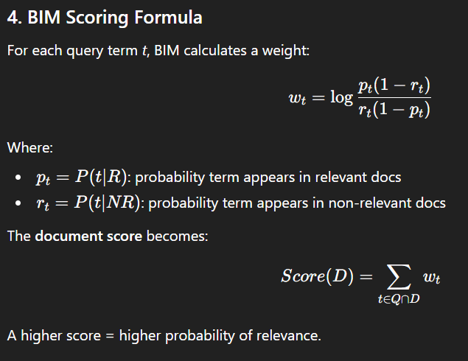

6. Strengths of BIM
- Mathematically sound and probabilistic.
- Simple to implement.
- Directly supports relevance feedback, making weights more accurate.
- Provides the conceptual foundation for the widely used BM25 ranking function.

7. Limitations of BIM
- Ignores term frequency (treats multiple occurrences as single).
- Assumes independent terms, which is unrealistic for correlated terms.
- Works best for short queries and simple collections.
- Cannot capture semantic relationships.

8. Importance and Applications
BIM is the theoretical root of modern retrieval models such as:
- BM25
- BM25F
- Probabilistic relevance model variants

Term Frequency (TF)
Term Frequency (TF) refers to the number of times a term appears in a document. It is an important factor in Information Retrieval because the more frequently a term appears in a document, the more likely it is that the document is relevant to that term or query.
Term Frequency is defined as:
TF(t,d)=number of times term t appears in document d
A higher TF value means the document discusses that term more prominently.

2. Importance in Retrieval Models
- TF helps differentiate between documents that merely mention a term and those that focus heavily on it.
- It improves ranking accuracy because a single occurrence does not carry the same importance as repeated occurrences.

3. TF in Probabilistic Models
Early probabilistic models like the Binary Independence Model ignored term frequency by using only term presence/absence.
However, modern models (e.g., BM25) include TF because:
- Multiple occurrences strengthen evidence of relevance
- TF helps distinguish highly relevant documents from marginal ones
Thus TF became a core component in advanced probabilistic IR.
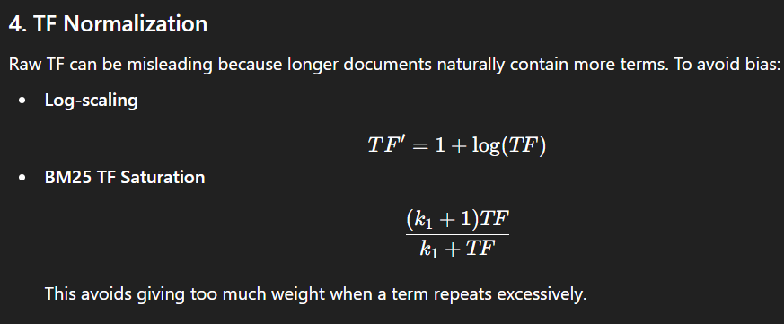

5. Role in Ranking
Higher TF means:
- Higher document relevance
- Higher ranking score
- Better matching of query intent
TF is combined with IDF (Inverse Document Frequency) to form scoring models like TF-IDF and BM25.

1. An Appraisal of Probabilistic Models – 6 Marks
Probabilistic models are one of the strongest theoretical approaches in Information Retrieval because they rank documents based on the probability of relevance. However, they also have limitations that lead to further improvements.

Strengths
- Strong Theoretical Foundation
Based on probability theory and the Probability Ranking Principle (PRP), making them mathematically sound.
- Effective Ranking
Models like BM25 provide high retrieval performance and are widely used in modern search engines.
- Supports Relevance Feedback
Probabilities can be refined as the user marks documents as relevant or not, improving accuracy.
- Clear Interpretability
Each term contributes to relevance in a measurable way (e.g., RSJ weights).

Weaknesses
- Term Independence Assumption
Probabilistic models assume terms occur independently, which is unrealistic (e.g., “machine learning”, “data mining”).
- Binary Term Representation
Early models like BIM ignored term frequency, losing important relevance information.
- Difficulty Estimating Probabilities
Impossible to know true relevance probabilities; models rely on approximations.
- Limited Semantic Understanding
They cannot capture synonyms, context, or deep linguistic meaning.

Tree-Structured Dependencies Between Terms
Early probabilistic models assume independence between terms, but in real text, terms often have meaningful relationships. Tree-structured dependency models were introduced to capture these relationships more accurately.
Terms in a document are rarely independent. Examples:
- “machine” and “learning”
- “artificial” and “intelligence”
Ignoring such dependencies reduces retrieval accuracy.

2. Tree-Structured Model Concept
- Terms are represented as nodes in a tree.
- Edges represent dependencies (correlation or co-occurrence strength).
- The structure allows modeling how the presence of one term influences the probability of another.

3. How It Improves IR
- Captures relationships like synonymy, phrase structure, and co-occurrence patterns.
- Improves estimation of P(t∣R) and overall relevance scoring.
- Reduces the unrealistic independence assumption of BIM.
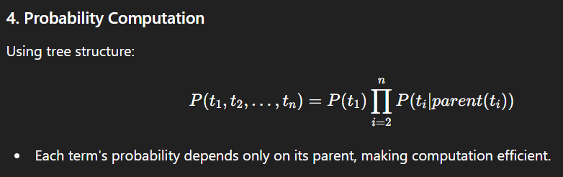

5. Applications
- Query expansion
- Better relevance modeling
- Basis for more advanced models like Bayesian networks and Markov Random Fields

Okapi BM25: A Non-Binary Model
Okapi Best Match 25 is one of the most widely used probabilistic ranking functions in Information Retrieval. It is considered the gold standard baseline in IR research. It evolved from the Binary Independence Model (BIM) but removed its major limitations by incorporating term frequency, document length normalization, and saturation effects. BM25 is considered the best classical IR model and is used in engines like Lucene, ElasticSearch, Solr, and Terrier. BM25 was created to address these practical needs.
Earlier models like BIM treated terms as binary (present/absent).
However, real-world retrieval needs:
- Term Frequency (TF) contribution
- Importance of rare terms (IDF)
- Document Length Normalization
- Controlled TF saturation (avoiding overweighting repeated terms)
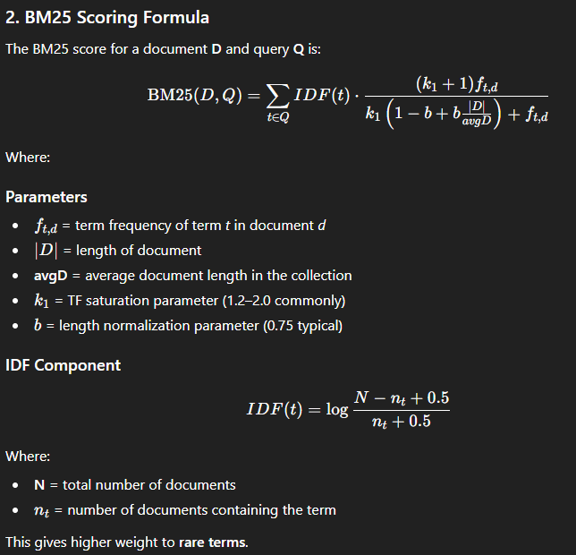
3. Key Features of BM25
(a) Non-binary Term Frequency
Uses term frequency (TF); more occurrences increase relevance but with saturation.
(b) Document Length Normalization
Uses parameter b to reduce bias toward long documents.
(c) TF Saturation (k₁ parameter)
Initial term occurrences matter more; repeated terms add less weight.
(d) IDF Weighting
Rare terms get higher importance; common terms get lower weight.

4. Why BM25 Works So Well
- Captures real-world document behavior
- Smooth, balanced scoring mechanism
- Highly interpretable and tunable
- Works for both short keywords and long text queries
- Robust across domains and datasets

5. Advantages of BM25
- Incorporates TF meaningfully
- Length normalization prevents bias
- No strict independence assumptions
- Handles multiple query terms effectively
- Fast to compute and easy to implement

6. Limitations
- Assumes bag-of-words (no semantic understanding)
- Parameters (k1, b) require tuning for best performance
- Does not use contextual meaning or phrase-level matching.

Bayesian Network Approaches to IR
A Bayesian Network (BN) is a probabilistic graphical model that represents variables and their conditional dependencies using a directed acyclic graph (DAG). In Information Retrieval (IR), Bayesian networks are used to model relationships between terms, documents, and relevance in a more flexible way than traditional probabilistic models like BIM.
Traditional probabilistic models assume:
- Independence between terms
- Binary term representation
- Limited structure in probability computation
These assumptions are unrealistic in real-world text, where terms are related (e.g., “artificial” + “intelligence”).
Bayesian networks overcome these limitations by explicitly modeling dependencies.

2. Structure of a Bayesian Network in IR
The network consists of nodes and directed edges:

Nodes represent:
- Query terms (T₁, T₂, …)
- Documents (D₁, D₂, …)
- Relevance variable (R)

Edges represent:
- Probabilistic dependencies between terms
- Influence of terms on documents
- Influence of document features on relevance
Example structure:
Terms → Document → Relevance

3. Probabilistic Representation
Each node has a conditional probability table (CPT) that quantifies relationships.
Example:
If a document contains both query terms (T₁=1, T₂=1):
P(R)=P(D∣T1,T2)×P(R∣D)
P(R)=0.8×0.9=0.72
These probabilities combine to compute the final relevance score.

4. Inference for Ranking
Document ranking is based on computing:
P(R=1∣T1,T2,...,Tn)
Using Bayesian inference:
P(R∣T)=∑D P(R∣D)⋅P(D∣T)
Documents with higher probabilities are ranked higher.
5. Advantages of Bayesian Networks in IR
(a) Captures Term Dependencies
Models relationships like synonymy, co-occurrence, and semantic similarity between terms.
(b) Handles Uncertainty Naturally
Combines uncertain evidence using probability theory.
(c) Supports Query Expansion
Helps identify related or missing query terms through dependencies.
(d) Flexible Structure
Terms, documents, fields, and user behavior can all be represented as nodes.
(e) Multiple Evidence Integration
Can incorporate metadata, link structure, and user interactions.

6. Drawbacks
- High computational complexity for large vocabularies.
- Requires learning the network structure, which is difficult.
- Parameter estimation for CPTs can be expensive.
- Not as fast or scalable as BM25 or vector models.

7. Applications in IR
- Query expansion and refinement
- Modeling term-term correlations
- Filtering noisy results
- Expert and domain-specific retrieval systems
- Adaptive IR based on user feedback
Types of Bayesian Networks
A Bayesian Network (BN) is a probabilistic graphical model that represents a set of random variables and their conditional dependencies using a Directed Acyclic Graph (DAG). Each node represents a variable, and directed edges encode conditional probability relationships. Different types of Bayesian networks are designed to balance model complexity, expressiveness, and computational efficiency.
1. General (Standard) Bayesian Network
This is the most flexible and expressive form of a Bayesian network.
Theory Points:
- Represented as a directed acyclic graph
- Each node has a Conditional Probability Table (CPT)
- Encodes the full joint probability distribution compactly
- Conditional independence reduces computational complexity
- Structure can represent complex dependency patterns
Applications: Diagnosis systems, risk analysis, expert systems
2. Naïve Bayes Network
Naïve Bayes is a highly simplified Bayesian network used mainly for classification.
Theory Points:
- Consists of one parent class node and multiple feature nodes
- Assumes conditional independence of features given the class
- Simplifies probability estimation and inference
- Works well even with small datasets
- Robust to irrelevant features
$$P(C∣X)∝P(C)\prod_{i}{P(}X_{i}∣C)$$
Applications: Spam filtering, text classification, sentiment analysis
3. Tree-Augmented Naïve Bayes (TAN)
TAN relaxes the strong independence assumption of Naïve Bayes.
Theory Points:
- Each feature depends on the class variable and at most one other feature
- Allows limited feature dependencies
- Retains efficient inference
- Improves classification accuracy over Naïve Bayes
- Learned using maximum spanning tree algorithms
Applications: Medical diagnosis, bioinformatics
4. Dynamic Bayesian Network (DBN)
Dynamic Bayesian Networks extend Bayesian networks to model time-dependent systems.
Theory Points:
- Represent variables across multiple time slices
- Capture temporal dependencies using state transitions
- Assumes first-order Markov property
- Generalizes Hidden Markov Models (HMMs)
- Supports filtering, prediction, and smoothing
Applications: Speech recognition, time-series forecasting, tracking
5. Causal Bayesian Network
Causal Bayesian Networks explicitly model cause-and-effect relationships.
Theory Points:
- Directed edges represent causal influence
- Enable reasoning about interventions
- Support counterfactual analysis
- Distinguish correlation from causation
- Based on causal assumptions and domain knowledge
Applications: Policy analysis, healthcare decision support, economics

Relevance Feedback in Information Retrieval
Relevance Feedback (RF) is a technique in Information Retrieval where the user’s judgments about which retrieved documents are relevant are used to improve the performance of the retrieval system.

1. Basic Concept of Relevance Feedback
After the user submits an initial query:
- System retrieves a set of documents.
- User marks some documents as relevant or non-relevant.
- System uses this information to recalculate term weights or modify the query model.
- New ranking is performed, usually yielding better results.
This process is iterative and continues until the user is satisfied.

2. Purpose of Relevance Feedback
- To refine the user’s query
- To learn which terms are truly useful
- To enhance recall and precision
- To reduce the effect of ambiguous or incomplete queries
RF transforms a short, vague, or imprecise query into a more effective one.

3. Types of Relevance Feedback

(a) Explicit Relevance Feedback
User directly selects relevant/non-relevant documents.
Highly accurate but requires user effort.

(b) Implicit Relevance Feedback
System infers relevance automatically through:
- Click-through data
- Time spent on documents
- User interaction patterns
Less accurate but easier to gather.

(c) Pseudo Relevance Feedback (Blind RF)
Assumes the top-k retrieved documents are relevant and updates query model accordingly.
Common in modern IR systems.

Relevance Feedback in Probabilistic Models
In probabilistic IR models, relevance feedback is used to update the importance of terms based on which documents the user marks as relevant or non-relevant.
If a term appears often in documents judged relevant, the system increases its weight because the term is a good indicator of relevance. If a term appears mostly in non-relevant documents, its weight is reduced. This updating process is called RSJ weighting (Robertson–Sparck Jones weighting).
By adjusting term importance based on user feedback, the probabilistic model becomes more accurate and ranks future documents more effectively.

Relevance Feedback in Vector Space Models – Rocchio Algorithm
In vector space models, the Rocchio Algorithm modifies the original query using information from relevant and non-relevant documents.
- Terms from relevant documents are given more weight, pulling the query closer to useful content.
- Terms from non-relevant documents are reduced, pushing the query away from unwanted content.
- Part of the original query is kept to preserve user intent.
The result is an improved query that better represents what the user actually wants, giving more accurate and relevant search results.

6. Advantages of Relevance Feedback
- Improves Retrieval Quality
Usually increases both precision and recall.
- Reduces Query Ambiguity
Helps when the user’s initial query is vague or short.
- Learns User Intent
Adapts the system to user’s exact information need.
- Enables Query Expansion
Adds important terms from relevant documents.

7. Limitations of Relevance Feedback
- Users may not want to mark documents manually.
- Incorrect feedback can hurt performance.
- Computationally expensive for large datasets.
- Requires accurate UI and user cooperation.

Field Weights: BM25F (9 Marks)
BM25F is an extension of the popular BM25 ranking model, designed to handle structured documents that contain multiple fields such as title, body, abstract, URL, headings, etc.
Since different fields contribute differently to relevance, BM25F introduces field weights to give more importance to certain fields over others.

1. Need for Field Weighting
Documents on the web or digital libraries are not uniform. A term appearing in the title is more important than the same term appearing in the body.
Examples:
- Title → very strong indicator of relevance
- Headings/subtitles → moderately important
- Body → normal importance
- Metadata/tags → high importance
BM25F solves this by applying different weights to different fields.

2. Core Idea of BM25F
Instead of using a single term frequency for the entire document, BM25F:
- Looks at each field separately
- Applies field-specific weights
- Combines them into a single score
This allows the ranking model to respect the structure of the document.

3. Components Used in BM25F
BM25F extends BM25 by incorporating:

(a) Field Term Frequency (FTF)
Term frequency is computed separately for each field.

(b) Field Weights
Each field has a predefined importance value.
For example:
- Title weight > Body weight
- Abstract weight > Body weight

(c) Field Length Normalization
Each field may have different lengths.
Longer fields get lower weight; shorter fields get higher weight.

(d) Combined Score
The weighted and normalized frequencies from all fields are merged into a single score, similar to BM25’s scoring mechanism.

4. Why Field Weights Improve Ranking
- Title matches are more meaningful than body matches.
- Metadata, captions, or tags can strongly indicate relevance.
- Helps avoid bias toward long fields (like large document bodies).
- Increases precision by using structural cues of the document.
BM25F is especially useful in web search engines and digital libraries.

5. Advantages of BM25F
- More accurate ranking for structured documents
- Flexible system where each field's importance can be tuned
- Better retrieval performance than plain BM25 when documents have fields
- Handles fields like title, URL, headings, keywords, etc.
- Works extremely well for web search where structure matters

6. Limitations
- Requires manual tuning of field weights (title vs body).
- Slightly more computationally expensive than BM25.
- Not effective if field weights are poorly chosen.
- Cannot capture deeper semantic meaning—still bag-of-words.
Language Models for Information Retrieval: Generating Queries from Documents
Information Retrieval (IR) focuses on finding relevant documents for a given user query. Traditional IR systems treat queries as fixed inputs and rank documents based on similarity measures. Language Models (LMs) introduce a probabilistic framework where documents and queries are modeled as probability distributions over terms. One important approach in LM-based IR is generating queries from documents, where each document is treated as a language model that could generate the user’s query.
Language Modeling Approach to IR
In the language modeling framework, each document $d$is assumed to define a probability distribution over words. The core idea is to rank documents by the probability that the document’s language model generates the query $q$.
$$P(d∣q)∝P(q∣d)P(d)$$
Since $P(d)$is usually assumed uniform, ranking depends mainly on $P(q∣d)$.
Query Generation from Documents
- A document language model $M_{d}$is constructed for each document.
- The probability of a query given a document is calculated as:
$P(q∣d)=\prod_{i=1}^{n}{P(}w_{i}∣d)$ where:
- $q=\{w_{1},w_{2},...,w_{n}\}$is the query,
- $P(w_{i}∣d)$is the probability of word $w_{i}$occurring in document $d$.
Documents that assign higher probability to generating the query are considered more relevant.
Smoothing Techniques
Direct estimation of $P(w∣d)$can lead to zero probabilities for unseen words. Smoothing is used to overcome this problem.
Common smoothing methods:
- Jelinek–Mercer smoothing
- Dirichlet smoothing
Advantages of Query Generation Approach
- Provides a strong probabilistic foundation for IR.
- Naturally integrates term frequency and document length normalization.
- Performs well for short queries.
- Avoids heuristic similarity measures.
Limitations
- Assumes query terms are generated independently.
- Sensitive to smoothing parameter selection.
- Computationally expensive for large document collections.
- Does not directly capture semantic relationships.
Language Models: Finite Automata and Language Models
A language model defines a set of valid strings (sentences) over an alphabet and assigns probabilities to them. In computer science and information processing, finite automata are one of the earliest and simplest formal models used to represent languages. Language models built using finite automata are fundamental in areas such as lexical analysis, pattern matching, and basic natural language processing.
Finite Automata
A finite automaton (FA) is a mathematical model of computation used to recognize patterns and define formal languages.
A finite automaton is defined as a 5-tuple:
$$\left(Q , Σ , δ , q_{0} , F\right)$$
where:
- $Q$is a finite set of states
- $Σ$is a finite input alphabet
- $δ$is the transition function
- $q_{0}$is the start state
- $F$is the set of accepting states
Finite automata can be:
- Deterministic Finite Automata (DFA)
- Non-Deterministic Finite Automata (NFA)
Both DFAs and NFAs recognize regular languages.
Finite Automata as Language Models
Finite automata can be viewed as language models by defining which strings are allowed or disallowed. A string is accepted if there exists a sequence of transitions from the start state to a final state.
In this context:
- The automaton defines the structure of the language
- All accepted strings belong to the language $L$
- Rejected strings are not part of the language
Probabilistic Finite Automata
To model uncertainty and variability in language, finite automata can be extended to Probabilistic Finite Automata (PFA).
In a probabilistic FA:
- Each transition has an associated probability
- The sum of outgoing transition probabilities from a state equals 1
- The probability of a string is the product of transition probabilities along its path
$$P(w)=\prod_{i}{P(}q_{i+1}∣q_{i},w_{i})$$
This makes finite automata suitable as statistical language models.
Advantages
- Simple and mathematically well-defined
- Efficient string recognition
- Suitable for regular patterns and local dependencies
- Widely used in lexical analyzers and speech recognition
Limitations
- Cannot model long-range dependencies
- Limited to regular languages
- Not suitable for complex natural language syntax
- State explosion problem for large vocabularies
Types of Language Models
A language model (LM) is a mathematical framework that assigns probabilities to sequences of words. It captures the structure, syntax, and statistical regularities of language and is a core component of many natural language processing systems such as speech recognition, machine translation, and information retrieval.
1. Rule-Based Language Models
Rule-based language models rely on explicitly defined grammatical and syntactic rules designed by linguists or domain experts. Based on formal grammar such as context-free grammar (CFG)
- Follow deterministic rules for sentence construction
- No learning from data is involved
- All valid sentences must strictly conform to predefined rules
Limitations:
- Difficult to cover all language variations
- Poor handling of ambiguity and real-world language usage
2. Statistical N-gram Language Models
N-gram models estimate the probability of a word based on a fixed number of previous words, using the Markov assumption. $P(w_{1},w_{2},...,w_{n})=\prod_{i=1}^{n}{P(}w_{i}∣w_{i-1},...,w_{i-(n-1)})$
- Common types: Unigram, Bigram, Trigram
- Probabilities are estimated from large text corpora
- Use smoothing techniques to handle unseen word sequences
- Capture local word dependencies effectively
Limitations:
- Cannot model long-range dependencies
- Suffers from data sparsity for large $n$
3. Finite Automata-Based Language Models
These models represent language using finite states and transitions between them. Each state represents a word history or context
- Transitions represent possible next words
- Can be deterministic or probabilistic
- Closely related to regular languages
Limitations:
- Limited expressive power
- State explosion for large vocabularies
4. Neural Network Language Models
Neural language models use neural networks to learn continuous representations of words and contexts.Replace discrete word counts with dense vector embeddings
- Learn complex syntactic and semantic relationships
- Use backpropagation for parameter optimization
- Can model variable-length context using RNNs and LSTMs
Advantages:
- Better generalization than n-gram models
- Reduced sparsity issues
5. Transformer-Based Language Models
Transformer models rely on self-attention mechanisms to model relationships between all words in a sequence.
- Eliminate recurrence and convolution
- Self-attention captures global context efficiently
- Support bidirectional and autoregressive modeling
- Enable large-scale pretraining and fine-tuning
Advantages:
- Handle long-range dependencies
- Achieve state-of-the-art results in NLP tasks
Multinomial Distributions over Words
In statistical language modeling and information retrieval, documents are often represented using the bag-of-words assumption, where the sequence of words is ignored and only word frequencies are considered. A multinomial distribution over words provides a probabilistic model to describe how words are generated within a document or query from a fixed vocabulary.
Vocabulary and Sample Space
- Let the vocabulary be $V=\{w_{1},w_{2},...,w_{∣V∣}\}$
- Each word corresponds to a distinct outcome of a random variable
- A document is treated as a sequence of independent word draws from this vocabulary
- The document length is fixed, but word occurrences can repeat
Multinomial Language Model
Each document $d$is associated with a parameter vector:
$$θ_{d}=(P(w_{1}∣d),P(w_{2}∣d),...,P(w_{∣V∣}∣d))$$
Theoretical properties:
- $\sum_{i=1}^{∣V∣}{P(}w_{i}∣d)=1$
- Each parameter represents the relative importance of a word in the document
- The model defines a probability distribution over all possible documents
Generative Assumptions
- Words are generated independently of each other
- Word order does not affect meaning
- The probability of a word depends only on the document model
- All words are drawn from the same vocabulary
Parameter Estimation (Maximum Likelihood)
The most common estimation method is Maximum Likelihood Estimation (MLE):
$$P(w∣d)=\frac{tf(w,d)}{∣d∣}$$
Theoretical implications:
- Directly reflects empirical word frequency
- Overfits small documents
- Produces zero probabilities for unseen words
Role in Information Retrieval
- Documents are ranked by the probability of generating a query
- Queries are also modeled as multinomial distributions
- Similarity between query and document is computed probabilistically
- Provides a theoretical alternative to TF-IDF and vector space models
Advantages
- Mathematically simple and interpretable
- Efficient for large text collections
- Strong probabilistic foundation
- Easy integration with smoothing and Bayesian methods
Limitations
- Ignores word order and syntax
- Assumes conditional independence
- Cannot model semantics or context
- Performance degrades for short documents
Divergence from Randomness (DFR)
Divergence from Randomness (DFR) is a probabilistic ranking framework in Information Retrieval that ranks documents based on how much the observed occurrence of query terms in a document deviates from what is expected by chance. The key idea is that informative terms occur non-randomly in relevant documents.
2. Randomness Hypothesis
DFR assumes that if a document is not relevant, the distribution of terms in it follows a random process. When a term appears more frequently than predicted by this random model, it provides evidence of relevance.
3. Measuring Divergence
The importance of a term is measured by the information content gained when its observed frequency diverges from randomness:
$$Information(t)=-{log⁡}_{2}P_{random}(t)$$
Lower probability under randomness implies higher information and higher relevance.
4. Randomness Models
To estimate $P_{random}(t)$, DFR uses probabilistic distributions like:
- Binomial model
- Poisson model
- Geometric model
These models define how terms would behave if they occurred randomly in documents.
5. Term Frequency Normalization
Since longer documents naturally contain more terms, DFR applies normalization to adjust term frequency based on document length. This ensures that relevance is due to term informativeness rather than document size.
6. After-Effect (Risk Hypothesis)
DFR includes an after-effect component which models the risk of accepting a document as relevant after seeing a term. The first occurrence of a term contributes more information than repeated occurrences, reducing redundancy.
7. Document Ranking
The final score of a document is computed by summing the divergence contributions of all query terms, including randomness divergence, normalization, and after-effect. Documents with higher total divergence are ranked higher.
Passage Retrieval and Ranking
Passage Retrieval is an information retrieval technique in which small text segments (passages) are retrieved and ranked instead of entire documents. This approach is useful when only a specific part of a document is relevant to a user query. Ranking determines the order of retrieved passages based on their relevance.
In long documents, relevant information may be confined to a few sentences or paragraphs. Retrieving full documents can reduce precision. Passage retrieval improves:
- Relevance accuracy
- Focused information access
- User satisfaction in question answering systems
Thus, ranking passages instead of documents provides more precise results.
3. Passage Generation
Documents are divided into passages using:
- Fixed-length windows (e.g., N sentences)
- Paragraph-based segmentation
- Overlapping sliding windows
Each passage is treated as an independent retrieval unit.
4. Passage Representation
Each passage is represented using:
- Bag-of-words or vector representation
- Term frequency statistics
- Language model probabilities
This allows passages to be compared directly with the query.
5. Passage Ranking Principle
Passages are ranked based on their relevance score with respect to the query. In probabilistic models, ranking is often based on query likelihood:
$$Score(p,q)∝P(q∣p)$$
Passages that better explain or generate the query receive higher ranks.
6. Scoring and Normalization
Since passages vary in length, normalization is applied to avoid bias toward longer passages. Ranking functions may include:
- Term frequency normalization
- Length normalization
- Smoothing in language models
This ensures fair comparison between passages.
7. Advantages of Passage Ranking
- Higher precision than document-level ranking
- Better support for question answering
- Faster access to exact information
- Improved handling of long documents
Problems Associated with N-gram Models and Their Solutions
An n-gram model is a statistical language model that predicts a word based on the previous $n-1$words. Although simple and widely used, n-gram models suffer from several practical and theoretical limitations.
1. Data Sparsity Problem
As $n$increases, the number of possible n-grams grows exponentially. Many valid word sequences do not appear in the training corpus, even if the corpus is large.
- Use smoothing techniques such as Laplace, Good-Turing, or Kneser–Ney smoothing
- Reduce the value of $n$(bigram or trigram models)
2. Zero Probability Problem
If an n-gram never occurs in training data, it is assigned a probability of zero, which makes the probability of the entire sentence zero.
- Apply smoothing to assign small non-zero probabilities to unseen n-grams
- Use backoff models, which fall back to lower-order n-grams
3. Limited Context
N-gram models consider only the previous $n-1$words and cannot capture long-range dependencies in language.
- Increase the value of $n$(with caution)
- Use interpolation combining multiple n-gram levels
- Replace with neural language models for long-context handling
4. Large Memory Requirement
Storing all possible n-grams and their probabilities requires large memory, especially for higher-order models.
- Use pruning techniques to remove low-frequency n-grams
- Apply compressed storage methods
- Limit vocabulary size
5. Poor GeneralizationN-gram models rely on exact word sequences and do not generalize well to unseen or rare word combinations.
- Use class-based n-gram models
- Apply word clustering
- Switch to neural embedding-based models
6. Sensitivity to Domain
An n-gram model trained on one domain performs poorly when applied to another domain.
- Use domain adaptation techniques
- Combine multiple corpora
- Fine-tune the model on domain-specific data
Challenges in Natural Language Processing (NLP)
NLP enables computers to understand and process human language. However, human language is complex, ambiguous, and highly contextual, which makes NLP challenging.
1. Ambiguity
Words and sentences can have multiple interpretations.
Example: “I saw the man with a telescope.”
It is unclear whether the man has a telescope or the observer used it.
2. Context Understanding
The meaning of words often depends on the surrounding text or situation.
Example: “It’s cold here.”
Could be a statement about temperature or a request to close a window.
3. Variability of Language
Different people, regions, or domains use language differently.
Example: “Big, large, huge” all convey the same idea but vary in usage.NLP systems must recognize synonyms, paraphrases, and style variations.
4. Long-Range Dependencies
Understanding relations between words far apart in a sentence is difficult.
Example: “The book that you gave me yesterday is interesting.”
“The book” is the subject, and “is interesting” is the verb phrase separated by intervening words.
5. World Knowledge and Common Sense
Understanding often requires external knowledge beyond the text.
Example: “The glass fell and broke.”
The model needs to know that falling objects made of glass usually break.
6. Noisy and Informal Text
Text from social media, chats, and SMS includes slang, abbreviations, typos, and emojis.
Example: “Gr8 job 👍”
NLP systems must interpret informal and noisy language correctly.

Different Levels of Natural Language Processing (NLP)
Natural Language Processing (NLP) involves analyzing, understanding, and generating human language using computational methods. NLP tasks are often organized into multiple levels, each focusing on different aspects of language.

1. Lexical Level
The lexical level deals with words and their structure. It focuses on identifying meaningful units of text and their forms.
Tasks at this level:
- Tokenization: Splitting text into words or sentences
- Stemming: Reducing words to their root form
- Lemmatization: Converting words to their dictionary form
- Morphological Analysis: Understanding word structure (prefix, root, suffix)
Example:
- Text: “The children were playing in the gardens.”
- Tokens: The, children, were, playing, in, the, gardens
- Stemmed forms: child, play, garden
Purpose: Helps in standardizing text and reducing redundancy.

2. Syntactic Level
The syntactic level analyzes sentence structure and grammatical relationships between words. It ensures that words are arranged in a grammatically correct way.
Tasks at this level:
- Part-of-Speech (POS) Tagging: Identifying nouns, verbs, adjectives, etc.
- Parsing: Constructing a parse tree representing sentence structure
- Grammar Checking: Detecting grammatical errors
Example:
- Sentence: “The cat sat on the mat.”
- POS Tags: The (Det), cat (Noun), sat (Verb), on (Prep), the (Det), mat (Noun)
- Parse Tree: Shows subject → verb → object relationships
Purpose: Provides syntactic structure for higher-level analysis.

3. Semantic Level
The semantic level deals with meaning of words and sentences. It captures the relationships between words and their meanings in context.
Tasks at this level:
- Word Sense Disambiguation (WSD): Identifying correct meaning of ambiguous words
- Named Entity Recognition (NER): Identifying entities like names, locations, dates
- Semantic Role Labeling: Understanding who did what to whom
Example:
- Word: “bank”
  - Financial institution: “I deposited money in the bank.”
  - River edge: “He sat on the river bank.”
Purpose: Enables systems to understand the actual meaning rather than just words.

4. Discourse Level
The discourse level analyzes meaning across multiple sentences and focuses on coherence and relationships between sentences.
Tasks at this level:
- Coreference Resolution: Identifying pronouns or phrases referring to the same entity
- Discourse Analysis: Understanding how sentences relate to each other
Example:
- Text: “John went to the park. He saw a dog.”
- Coreference: “He” refers to John.
Purpose: Ensures context and consistency in understanding long texts.

5. Pragmatic Level
The pragmatic level deals with intended meaning and real-world knowledge. It considers context, speaker intention, and social conventions.
Tasks at this level:
- Intent Detection: Understanding the purpose behind a statement
- Speech Act Recognition: Recognizing requests, commands, or questions
- Contextual Interpretation: Using world knowledge to understand implied meaning
Example:
- Sentence: “Can you open the window?”
- Literal meaning: Question about ability
- Intended meaning: Request to open the window
Purpose: Helps machines understand user intention beyond literal words.

